EXPERIMENT- 6
1.
# Dataset
sales <- data.frame(
Product = c("Product A", "Product B", "Product C"),
January = c(2000, 1500, 1200),
February = c(2200, 1800, 1400),
March = c(2400, 1600, 1100)
)

# Convert to matrix
sales_matrix <- as.matrix(sales[,2:4])
rownames(sales_matrix) <- sales$Product

# Grouped Bar Chart
barplot(sales_matrix,
beside = TRUE,
col = c("red", "green", "blue"),
main = "Monthly Product Sales (Q1)",
xlab = "Products",
ylab = "Sales",
legend.text = colnames(sales_matrix))
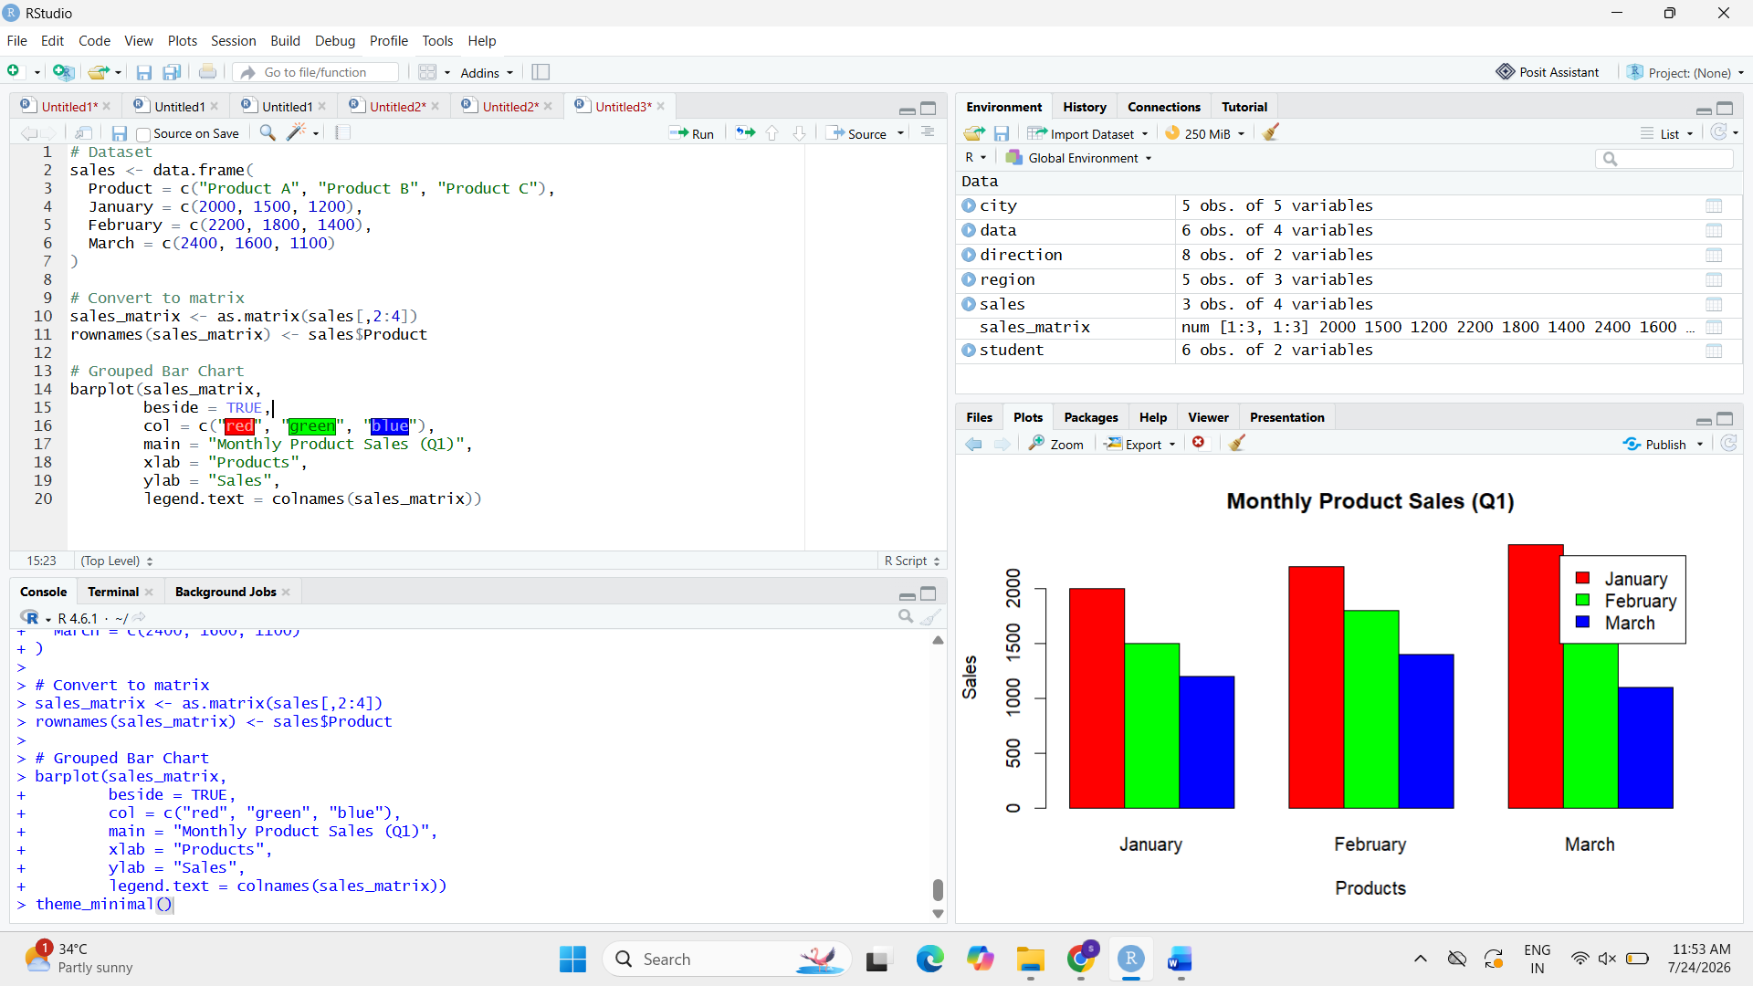

2.
# Dataset
sales <- data.frame(
Month = c("January", "February", "March"),
ProductA = c(2000, 2200, 2400),
ProductB = c(1500, 1800, 1600),
ProductC = c(1200, 1400, 1100)
)

# Install package (only first time)
# install.packages("ggplot2")
# install.packages("reshape2")

library(ggplot2)
library(reshape2)

# Convert to long format
sales_long <- melt(sales, id.vars = "Month")

# Stacked Area Chart
ggplot(sales_long,
aes(x = Month,
y = value,
fill = variable,
group = variable)) +
geom_area() +
labs(title = "Overall Sales Trend",
x = "Month",
y = "Sales",
fill = "Products")

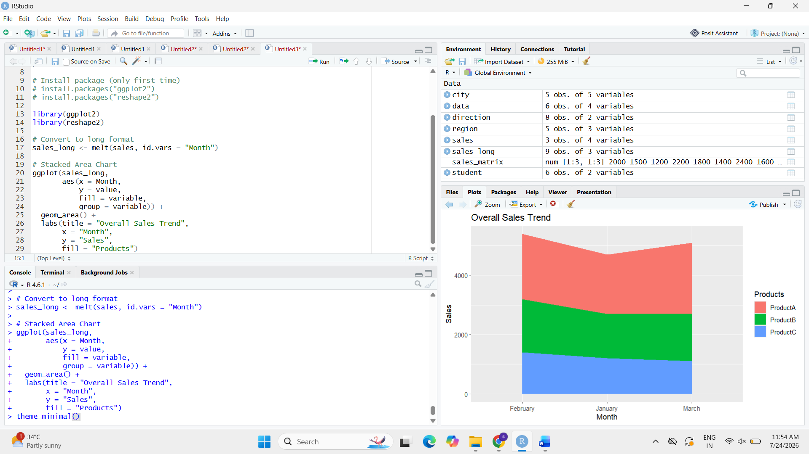

3.
sales <- data.frame(
Product = c("Product A", "Product B", "Product C"),
January = c(2000,1500,1200),
February = c(2200,1800,1400),
March = c(2400,1600,1100)
)

print(sales)

